**Ethiopia country profile**

Published

24 June 2019

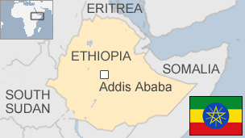

**Ethiopia is Africa's oldest independent country and its second largest in terms of population. Apart from a five-year occupation by Mussolini's Italy, it has never been colonised.**

It has a unique cultural heritage, being the home of the Ethiopian Orthodox Church - one of the oldest Christian denominations - and a monarchy that ended only in the coup of 1974.

It served as a symbol of African independence throughout the continent's colonial period, and was a founder member of the United Nations and the African base for many international organisations.

Drought and civil conflict left Ethiopia in a state of turmoil under a Marxist dictatorship from the fall of the monarchy until 1991, when the long authoritarian rule of Meles Zenawi brought a degree of stability.

Since 2018, Prime Minister Abiy Ahmed has launched a campaign of political liberalisation at home and sought to end disputes with Ethiopia's neighbours, in particular Eritrea.

* See [more country profiles](http://news.bbc.co.uk/1/hi/country_profiles/) - Profiles compiled by [BBC Monitoring](http://www.bbc.co.uk/monitoring)

**President: Sahle-Work Zewde**

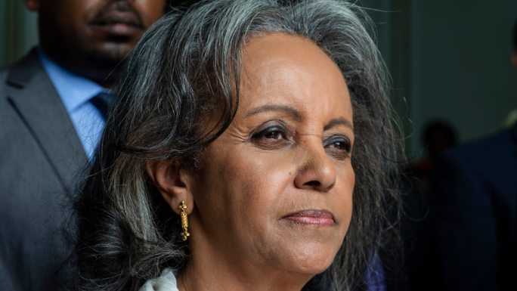image copyrightEDUARDO SOTERAS/AFP/Getty Images

image captionMs Sahle-Work is the first female head of state since Empress Zawditu (1928-1930)

Parliament elected Sahle-Work Zewde as the Ethiopia's first woman president in October 2018.

Ms Sahle-Work, an experienced diplomat, promised to work to make gender equality a reality at her swearing-in to the largely ceremonial post.

She took office a week after Prime Minister Abiy Ahmed appointed a cabinet with half the posts taken by women.

**Prime minister: Abiy Ahmed**

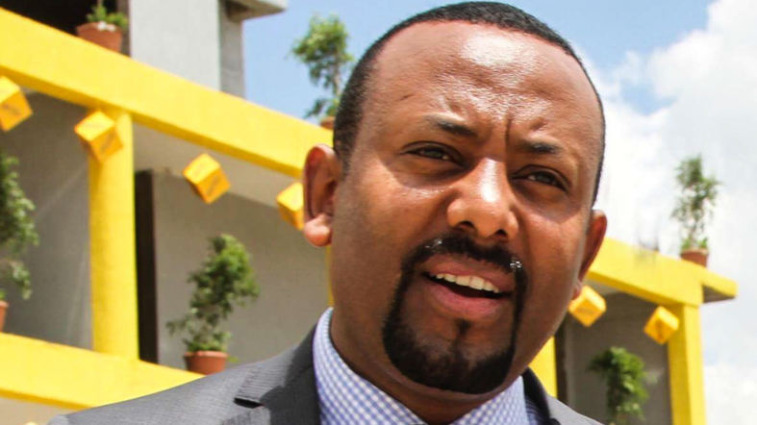image copyrightGetty Images

Abiy Ahmed was chosen to lead the ruling Ethiopian People Revolutionary Democratic Front coalition after the unexpected resignation of Prime Minister Hailemariam Desalegn in 2018.

The new leader pledged to try to end longstanding tensions with neighbouring Eritrea, and within months the two countries declared that the state of war between them was over.

Mr Abiy also pledged to bring more transparency to government and reconciliation to a country that had been torn by protests since 2015.

He is Ethiopia's first leader from the Oromo ethnic group, which has been at the centre of anti-government protests since 2016.

The prime minister faced the first major challenge to his political course in a coup attempt in Amhara State in June 2019. The army chief and governor of Amhara State were killed in putting down the coup.

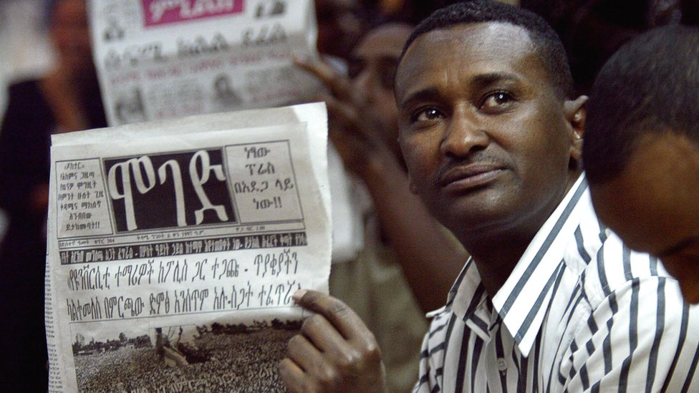image copyrightAFP

The change of government in 2018 looked set to usher in a new era for the media, which for many years had operated in one of the region's most restrictive environments.

The state controls most broadcasting outlets, including national broadcasters ETV and Radio Ethiopia.

Internet and mobile services have been restricted during periods of social unrest.

# Ethiopia profile - Timeline

Published

24 June 2019

## A chronology of key events:

**2nd century AD** - Kingdom of Axum becomes a regional trading power.

**4th century** - Christianity becomes state religion.

**1530-31** - Muslim leader Ahmad Gran conquers much of Ethiopia.

**1818-68** - Lij Kasa conquers Amhara, Gojjam, Tigray and Shoa.

**1855** - Kasa becomes Emperor Tewodros II.

**1868** - Tewodros defeated by a British expeditionary force and commits suicide to avoid capture.

**1872** - Tigrayan chieftain becomes Yohannes IV.

**1889** - Yohannes IV killed while fighting Mahdist forces and is succeeded by the king of Shoa, who becomes Emperor Menelik II.

**1889** - Menelik signs a bilateral friendship treaty with Italy at Wuchale which Italy interprets as giving it a protectorate over Ethiopia. Ethiopia rejects this interpretation, later renounces the treaty and repays a loan.

**1889** - Addis Ababa becomes Ethiopia's capital.

## Italy invades

**1895** - Italy invades Ethiopia.

**1896** - Italian forces defeated by the Ethiopians at Adwa. Treaty of Wuchale annulled, and Italy recognises Ethiopia's independence but retains control over Eritrea.

**1913** - Menelik dies and is succeeded by his grandson, Lij Iyasu.

**1916** - Lij Iyasu deposed and is succeeded by Menelik's daughter, Zawditu, who rules through a regent, Ras Tafari Makonnen.

**1930** - Zawditu dies and is succeeded by Ras Tafari Makonnen, who becomes Emperor Haile Selassie I.

**1935** - Italy invades Ethiopia.

**1936** - Italians capture Addis Ababa, Haile Selassie flees. Ethiopia combined with Eritrea and Italian Somaliland to become Italian East Africa.

## Haile Selassie's reign

**1941** - British and Commonwealth troops aided by the Ethiopian resistance defeat the Italians, and restore Haile Selassie.

**1952** - United Nations federates Eritrea with Ethiopia.

**1962** - Haile Selassie annexes Eritrea, which becomes an Ethiopian province.

**1963** - First conference of the Organisation of African Unity held in Addis Ababa.

## "Red Terror"

**1973-74** - An estimated 200,000 people die in Wallo province as a result of famine.

**1974** - Haile Selassie overthrown in military coup. General Teferi Benti becomes head of state.

**1975** - Haile Selassie dies in mysterious circumstances while in custody.

**1977** - Benti killed and replaced by Colonel Mengistu Haile Mariam.

**1977-79** - Thousands of government opponents die in "Red Terror" orchestrated by Mengistu; collectivisation of agriculture begins; Tigrayan People's Liberation Front launches war for regional autonomy.

**1977** - Somalia invades Ethiopia's Ogaden region.

**1978** - Somali forces defeated with massive help from the Soviet Union and Cuba.

**1984-85** - Worst famine in a decade strikes; Western food aid sent; thousands forcibly resettled from Eritrea and Tigre.

**1987** - Mengistu elected president under a new constitution.

**1988** - Ethiopia and Somalia sign a peace treaty.

## After Mengistu

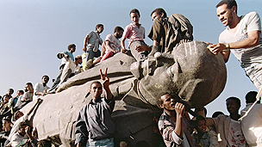image copyrightGetty Images

image captionEthiopians celebrate the end of an era on a toppled statue of the Russian revolutionary, Lenin

**1991** - Ethiopian People's Revolutionary Democratic Front captures Addis Ababa, forcing Mengistu to flee the country; Eritrea establishes its own provisional government pending a referendum on independence.

**1992** - Haile Selassie's remains discovered under a palace toilet, and reburied in Addis Ababa's Trinity Cathedral in 2000.

**1993** - Eritrea becomes independent following referendum.

**1994** - New constitution divides Ethiopia into ethnically-based regions.

**1995** - Meles Zenawi assumes post of prime minister.

## War with Eritrea

**1999** - Ethiopian-Eritrean border clashes turn into a full-scale war.

**2000** - Eritrea, Ethiopia sign a peace accord which envisage troop withdrawals and UN peacekeepers. A boundary commission is given the task of defining the border; it awards Badme to Eritrea, but Ethiopia's continued occupation of the town is a major source of friction.

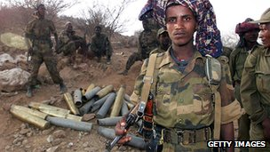image copyrightGetty Images

image captionBorder clashes with Eritrea turned into a full-scale war

**2004** January-February - Nearly 200 killed in ethnic clashes in isolated western region of Gambella. Tens of thousands flee area.

**2004** March - Start of resettlement programme to move more than two million people away from parched, over-worked highlands.

**2005** March - US-based Human Rights Watch accuses army of "widespread murder, rape and torture" against Gambella region's ethnic Anuak people. Military rejects charge.

**2005** April - First section of Axum obelisk, looted by Italy in 1937, is returned to Ethiopia from Rome.

## Disputed poll

**2005** May - Disputed multi-party elections lead to violent protests over months.

**2005** August-September - Election re-runs in more than 30 seats: Officials say the ruling party gains enough seats to form a government.

**2005** December - International commission, based in The Hague, rules that Eritrea broke international law when it attacked Ethiopia in 1998.

More than 80 people, including journalists and many opposition leaders, are charged with treason and genocide over November's deadly clashes.

## Somalia tensions

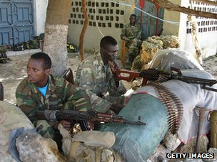image copyrightGetty Images

image captionEthiopian soldiers have fought Somali Islamists

**2006** November - Ethiopian troops enter Somalia, engage in fierce fighting with Islamists controlling large parts of the country and capital. The Islamists disperse.

**2006** December - Exiled former dictator Mengistu Haile Mariam is convicted, in absentia, of genocide at the end of a 12-year trial. He is later sentenced to death.

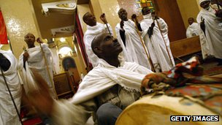image copyrightGetty Images

image captionThe new millennium dawned in 2007 in the calendar of the Coptic Orthodox Church

**2008** July - UN Security Council votes unanimously to end UN peacekeeping mission monitoring disputed border between Ethiopia and Eritrea.

**2008** September - Celebrations held to mark completion of reassembly of 1700-year-old Axum Obelisk, looted in 1937 during the Italian conquest and returned by Italy in three parts after 2005.

**2008** December - Police re-arrest key opposition leader Birtukan Medeksa, who was jailed for her role in the opposition protests after the 2005 polls, and freed under a government pardon in 2007.

**2009** June - Ethiopia admits to "reconnaissance missions" in Somalia despite formal withdrawal of troops in January, but denies re-deploying troops.

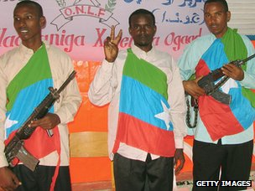image copyrightGetty Images

image captionRebels from the ethnic Somali Ogaden region are seeking regional autonomy

**2009** December - Rebels of the Ogaden National Liberation Front claim capture of several towns in the east in a month of heavy fighting.

**2010** May - Ruling Ethiopian People's Revolutionary Democratic Front (EPRDF) wins huge majority in parliamentary elections, handing Prime Minister Meles Zenawi a fourth term. International observers highlight shortcomings.

**2012** August - Prime Minister Meles Zenawi dies. Succeeded by Foreign Minister Hailemariam Desalegn in September.

**2015** May - Ruling EPRDF scores another victory in general election widely criticised by the opposition.

**2016** October - Government declares state of emergency following months of violent anti-government protests.

**2018** February - As anti-government protests continue, Prime Minister Desalegn resigns.

## Abiy reforms

**2018** April - Abiy Ahmed, an ethnic Oromo, wins over his challengers to become leader of the ruling EPRDF and therefore prime minister. He launches a comprehensive programme of political reform at home and diplomatic bridge-building abroad.

**2018** May-June - Government releases thousands of political prisoners, and lifts state of emergency.

**2018** July - Ethiopia and Eritrea declare their war is over as Ethiopia agrees to evacuate disputed territory.

**2018** October - The government signs a peace deal with the separatist Ogaden National Liberation Front (ONLF), ending a 34-year armed rebellion.

Parliament elects Sahle-Work Zewde as Ethiopia's first woman president, and first female head of state since Empress Zawditu (1928-1930).

**2019** March - Ethiopian Airlines plane crashes southeast of Addis Ababa, killing all 157 people on board, leading to grounding of Boeing 737 Max 8 planes around the world.

**2019** June - Army chief Seare Mekonnen and Amhara State Governor Ambachew Mekonnen killed while putting down coup attempt against the federal government.